1)
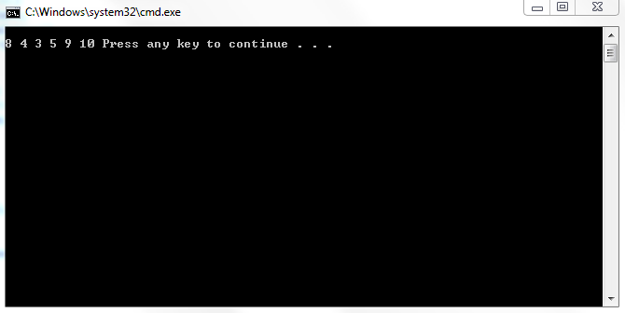
2)
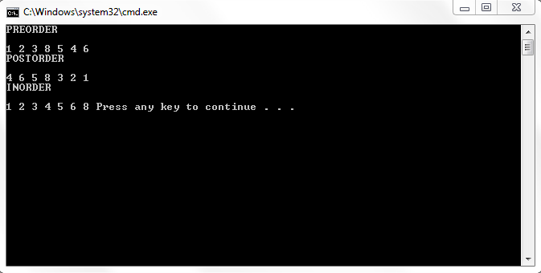
POSTLAB:
#include<iostream>
using namespace std;
class TreeNode {

public:

int value;
TreeNode* left;
TreeNode* right;
};

class TreeType {
TreeNode* root;
public:
TreeType(){root =NULL;};
void insertItem(int value);
void print();
void print_preorder(TreeNode * r);
int search(int val);

};
void TreeType::insertItem(int val)
{
TreeNode *tree = root;
TreeNode *temp= new TreeNode;
temp->left = NULL;
temp->right = NULL;
temp->value = val;
if(tree == NULL)
root=tree=temp;
else{
while(tree->left != NULL && tree->right !=NULL)
{
if(tree->value>val)
tree=tree->left;
else if(tree->value<val)
tree=tree->right;
}
if(tree->value>val)
tree->left=temp;
else if(tree->value<val)
tree->right=temp;
}
}
void TreeType::print()
{
cout<<endl;
print_preorder(root);

}
void TreeType::print_preorder(TreeNode *r)
{
if(r == NULL)
return;
else
{
cout << r->value<<" ";
print_preorder(r->left);
print_preorder(r->right);
}

}
int TreeType::search(int val)
{
TreeNode *tree = root;
int count =0;
bool found =false;
while(tree != NULL && !found)
{
if(tree->value==val)
{
count++;
found = true;
}
if(tree->value>val)
{
count++;
tree=tree->left;
}
else if(tree->value<val)
{
count++;
tree=tree->right;
}
}
if(found)
return count;
else
return -1;
}
void main() {
TreeType* MyTree = new TreeType;
MyTree->insertItem(8);
MyTree->insertItem(9);
MyTree->insertItem(4);
MyTree->insertItem(10);
MyTree->insertItem(3);
MyTree->insertItem(5);
cout<<"print\n";
MyTree->print();
cout<<"\nsearch\t "<<MyTree->search(3);
cout<<endl;
system("pause");
}

